**Day 5 | testing, error handling and backend**

**Step 1: Comprehensive Functional Testing**

**Objective:** Ensure that all core features of the marketplace function seamlessly, meeting expectations and delivering a smooth user experience. Key Features Tested:

1. Navigation Links: Confirm all links are fully operational and lead to the correct destinations

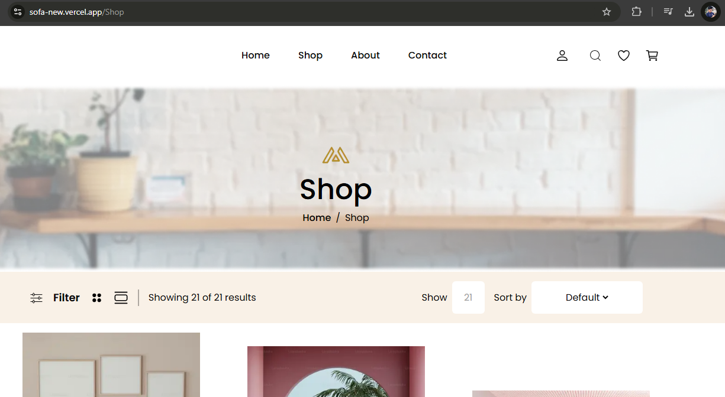

1. Product Listings & Details: Ensure products are displayed accurately, with complete information and images
2. Shopping Cart Operations: Test adding, updating, and removing items to verify cart functionalities are working as intended.



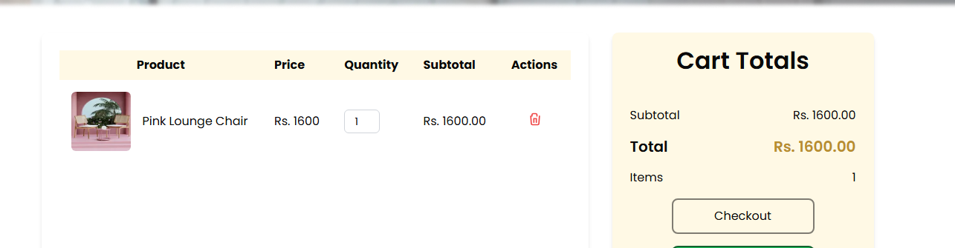

4. Blog Accessibility: Check that blog content is accessible to all users, including compatibility with assistive technologies.

5. Contact Form: Test the form’s submission process to ensure messages are successfully sent and received.

**Step 2: Seamless Error Management**

**Objective**: Develop robust error-handling strategies to ensure smooth user experiences and maintain trust.

**Implementation Plan**:

1. **Effective API Error Handling**: Employ try-catch blocks to gracefully manage API failures.

2. **Fallback UI Elements**: Display meaningful messages like "No products available" when data cannot be retrieved.

3. **Error Logging:** Implement error logging mechanisms for quick debugging and issue resolution.

4. User-Friendly Feedback: Provide clear, actionable messages for failed API responses to maintain interface reliability and user confidence.

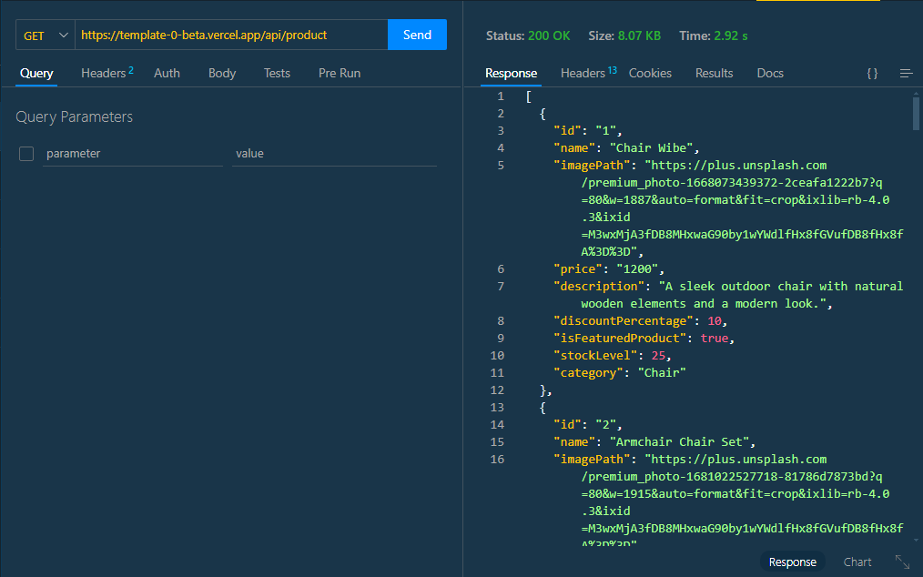

**Step 4: Comprehensive Cross-Browser and Device Testing**

**Objectie**: Guarantee consistent functionality, design integrity, and accessibility across all major browsers and devices.

Platforms & Tools:

1. Browsers Tested: Chrome, Firefox, Safari, Edge.

2. Devices Evaluated: Desktop, tablet, and mobile environments via BrowserStack.

**Key Focus Areas:**

1. **Responsive Design**: Validate fluid layouts that adapt seamlessly to different screen sizes and resolutions.

2. **Navigation Consistency**: Ensure smooth and predictable interactions across all platforms.

3**. Accessibility Verification:** Confirm robust keyboard navigation and compatibility with screen readers to cater to diverse user needs.

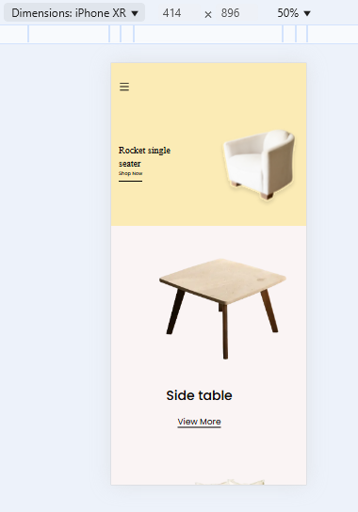

**Step05: Performance Optimization**

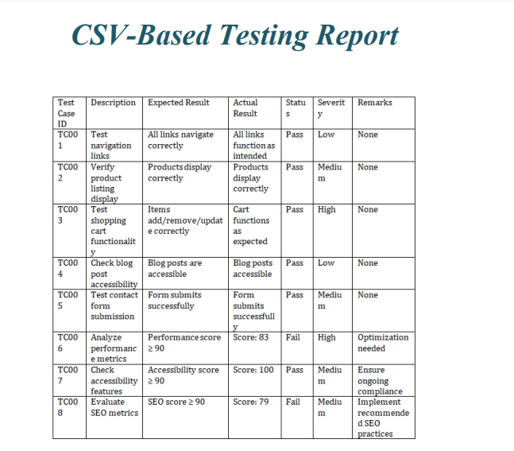

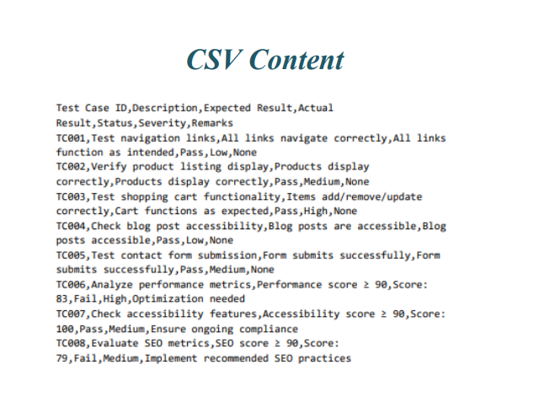

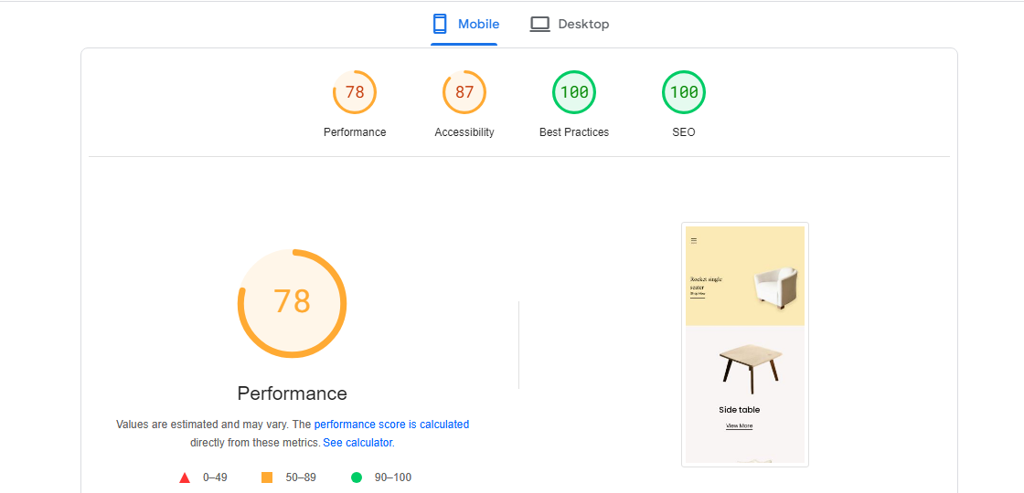

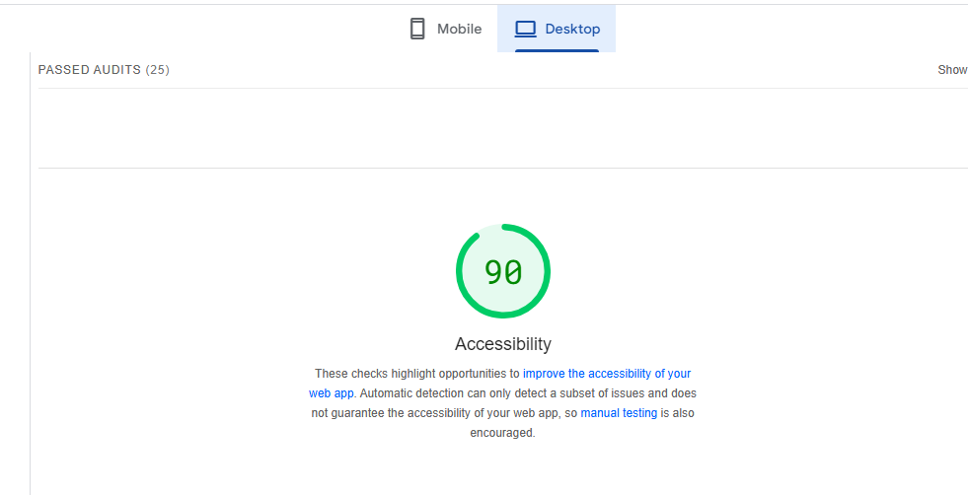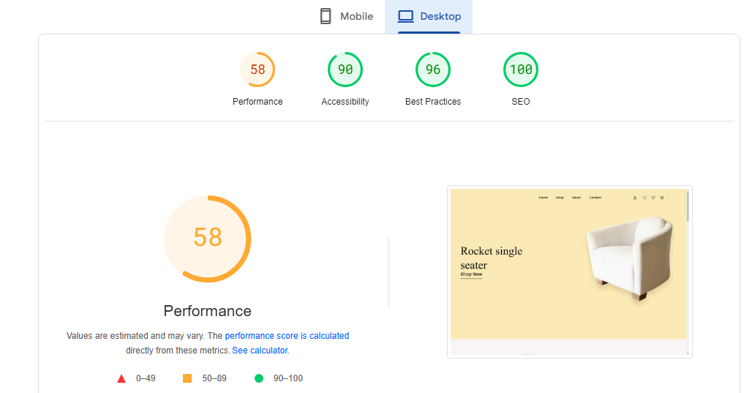

**Developer Resources**

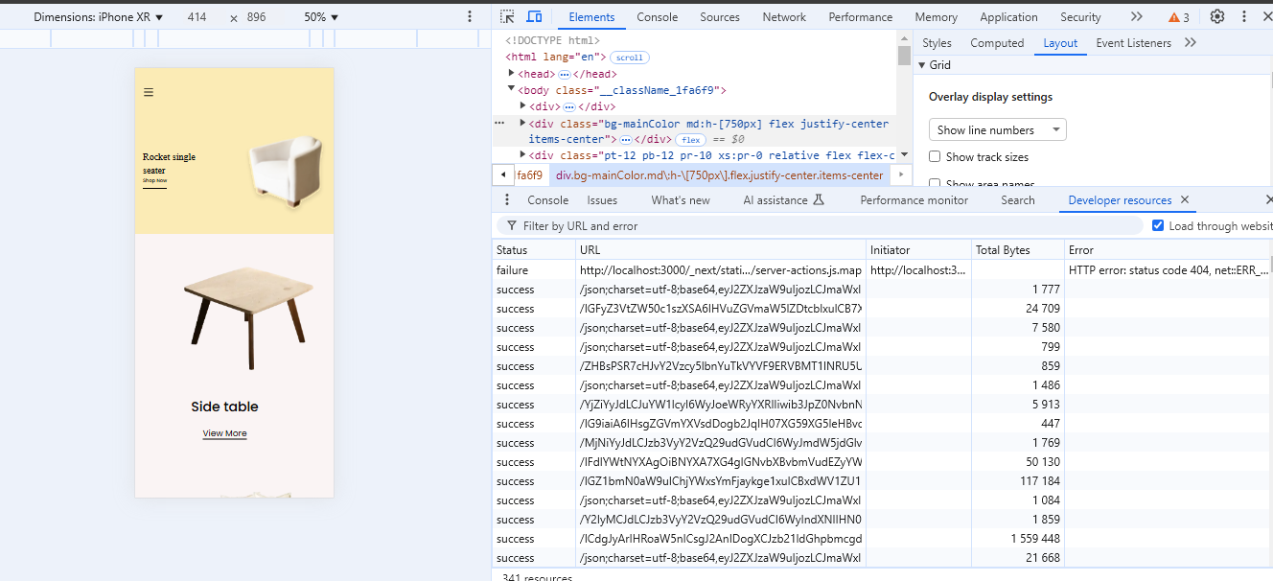

**Performance Monitor**

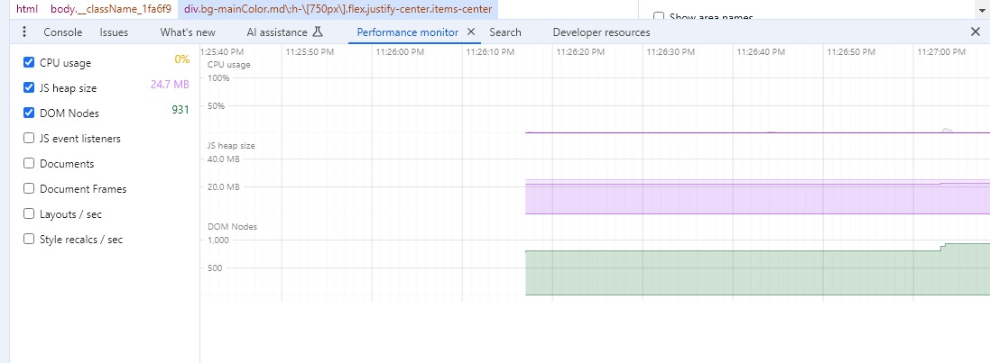

**Security OverView**

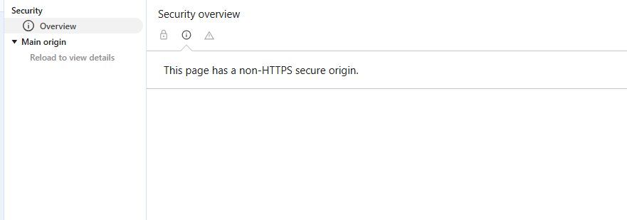

**Executive Summary:**

**Day 5 Overview**

The fifth day of development focused on reinforcing the marketplace platform's reliability, user experience, and overall performance. Through systematic testing and optimization, key functionalities were validated, and performance metrics were substantially improved. Though SEO and certain performance refinements remain in progress, the platform is now closer to being deployment-ready.

This report, alongside the accompanying CSV data, provides a comprehensive overview of actions taken and outlines the next steps toward final deployment.

**Key Achievements:**

**1. Comprehensive Testing and Validation:**

All major features, including navigation, product listing, cart functionality, and form submissions, were rigorously tested to ensure they perform as expected.

**2. Performance Optimizations:**

Optimization measures improved overall site performance, including reduced server response time, better image handling, and enhanced accessibility scores.

**3. SEO Enhancements in Progress:**

While initial SEO improvements were made, ongoing work will further enhance search engine visibility.

**Next Steps and Future Recommendations:**

1. **Continuous Performance Monitoring:**

Implement routine testing to continuously monitor and refine performance, ensuring scalability and speed as user traffic increases.

**2. AI-Powered Personalization:**

Introduce AI-driven recommendations for personalized user experiences, boosting customer engagement and conversions.

1. **Regular Security Audits:**

Establish a framework for periodic security audits to stay ahead of potential vulnerabilities and ensure the platform's ongoing protection